Siemens NX CAM User’s Guide

FOR

DMG DMC 80 Mono Block
With Heidenhian iTNC 530

April 27, 2008

1. Machine Description 1
2. Geometry Group 2
2.1 Local coordinate system 2
3. Special Programming Considerations 3
3.1 Point to Point or Hole Making Canned Cycle Procedures 3
3.2 Avoidance setting 3
3.3 UDE - 5axis control mode 3
4. Canned Cycles 4
4.1 Cycle 240: CENTERING 5
4.2 Cycle 200: DRILLING 6
4.3 Cycle 201: REAMING 6
4.4 Cycle 202: BORING 6
4.5 Cycle 207: RIGID TAPPING 6
5. Appendix A -- M-Code List 8
6. Appendix B -- Detailed MCS description 9

Statement of Confidentiality

The information contained in this document is confidential and proprietary ("Confidential Information") to Siemens. Siemens submits this Document with the express understanding that it will be held in strict confidence, will not be disclosed to any third party for any purpose, and will not be duplicated or used, in whole or in part, for any purpose other than the Siemens Machine Tool Support Kit implementation, without the express written consent of Siemens.

Machine Description

This Siemens NX CAM software covers the standard functionality that may be equipped on a DMG DMC 80 Mono Block machine tool. This documentation covers functionality for 5-axis simultaneous machining with Head-Table . Please ignore all references to equipment your machine tool does not have.

The Siemens NX CAM software can calculate and post-process this functionality.

- Support of M128(TCPM)

Maintaining the position of the tool tip when positioning with tilted axes
This process can occur in variable axis milling and sequential milling operations. Postprocessor will automatically decide which operation need M128 mode. The basic principle is tool axis is variable in cutting motion.

- Support of PLANE SPATIAL
In PLANE SPATIAL, user define the position of the working plane—i.e. the position of the tool axis referenced to the machine coordinate system.

- Support of Canned Cycles
Support for following four canned cycles- as detailed, within this documentation.
Cycle 240: CENTERING
Cycle 200: DRILLING
Cycle 201: REAMING
Cycle 202: BORING
Cycle 207: RIGID TAPPING

Geometry Group

The Geometry view of the ONT is used to determine which MCS (Machine Coordinate System) will be used. Each MCS determines where the NC code will be referenced to. This is important if you want have correct replay and verification.
The template or seed part provided has the MCS’s set up correctly in the Geometry view.

Local coordinate system
If user set up a local coordinate system please set the Special Output as “Use Main MCS”. This is very important to output correct WORK PLANE code.
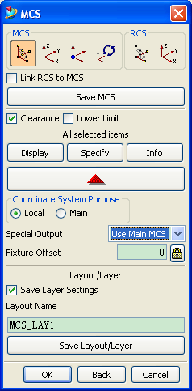

Special Programming Considerations

Point to Point or Hole Making Canned Cycle Procedures
A fundamental requirement for ALL canned cycle operations is to have an initial motion take place prior to invoking an actual canned cycle itself. Failure to have an initial motion prior to a canned cycle can lead to improper output results.
Please make sure you select the part surface in ALL canned cycle operations

Avoidance setting
In order to avoid the collision during the machining, the set the clearance plane properly in the operation.
Please set the correct Start Point in the canned cycle drilling operation.

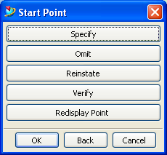

UDE - 5axis control mode
User may add UDE "5axis control mode" to operation to overwrite the automatic "M128/CYCL 19" output. This UDE is non-model. Which means the control mode only implemented in current operation with this UDE.
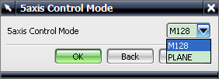

Canned Cycles
For output correct cycle type, please select corresponding point-to-point or hole making type in operation as below figure.
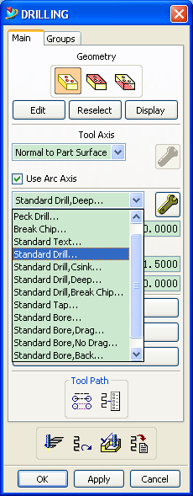

Cycle 240: CENTERING
For output cycle 240, please select “Standard Drill…” or “Standard Drill, Csink…”
Centering is based on the entered depth. Please use “Standard Drill”. Under this type, Q343=0.
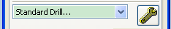
Note: For centering drilling based on depth, user should select “Tool Tip Depth” option as following figure.
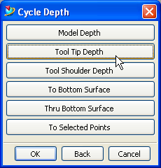
Centering is based on the entered diameter. Please use “Standard Drill, Csink”. Under this type, Q343=1.
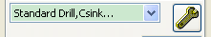
Note: Diameter should be entered in under dialog as Csink Diameter.
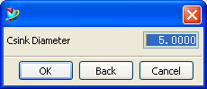
Please keep Entr Diam as 0.0, otherwise it will affect rapid to value.
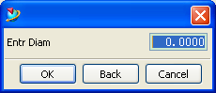

Cycle 200: DRILLING
For output cycle 200, please select “Standard Drill, Deep…” or “Standard Drill, Break Chip…”
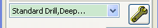
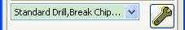
To output infeed per cut Q202, please assign value to Step #1.
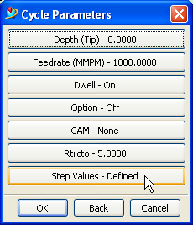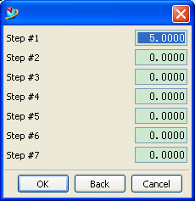

Cycle 201: REAMING
For output cycle 201, please select “Standard Bore…”
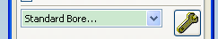

Cycle 202: BORING
For output cycle 202, please select “Standard Bore, Drag…”
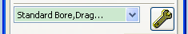

Cycle 207: RIGID TAPPING
For output cycle 207, please select “Standard Tap…”
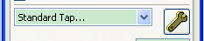
Note: Entering pith please input the value at “Cycle Feedrate” and make sure unit is MMPR.
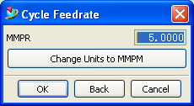

Appendix A -- M-Code List

M03 Spindle ON clockwise
M04 Spindle ON counterclockwise
M05 Spindle STOP
M08 Coolant- ON Mode: FLOOD
M09 Coolant- OFF Mode: FLOOD
M00 Stop
M01 Opstop
M30 End of Program
M91 Within the positioning block: Coordinates are referenced to machine datum
M128 Maintain the position of the tool tip when positioning with tilted axes (TCPM)
M129 Reset M128

Appendix B -- Detailed MCS description

NOTE: Without using the supplied Support Kit, the default MCS objects in the NX/CAM Geometry View of the Operation Navigator Tool (ONT) do not typically have a dialog for:
Coordinate System Purpose
Special Output
This may be the situation, for any user created, new MCS object (not from a Siemens supplied template for this NX/CAM Post). Whether for turning or live tool applications, a newly created MCS object must be customized, for the above mentioned topics to appear.
To add the above dialog options:
Right Mouse on the just created MCS – then → [Object → Customize] →Add these two items
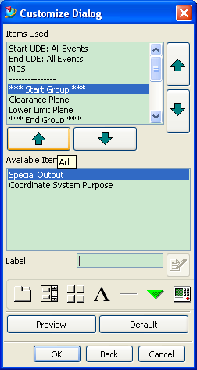

- - - - - - - - - - - - - - - - - - - - - - - - - - - - - - - - - - - - - - - - - - - - - - - - - - - - - - - - - -
File: Siemens_NX User Guide
Date: 04-21-2008

